**Gồm: 200, 301, 404, 400, 403, 500, 501**

1. 200 OK:

1. 301 MOVED PERNAMENT

1. 404 NOT FOUND:

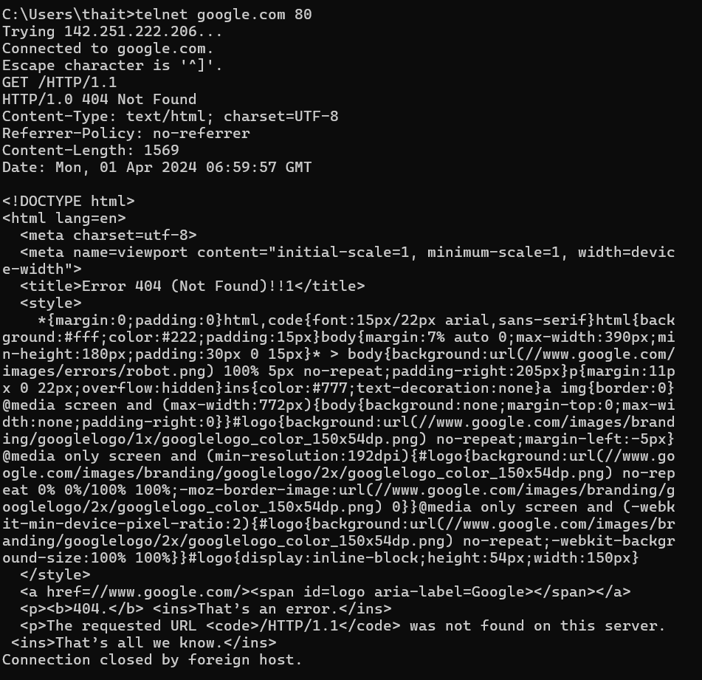

1. 400 Bad Request:

1. 403 Forbidden

1. 500 Domain Not Found

1. 501 Not Implemented

